Advanced Living Systems
Aquarium Water Chemistry

Time: 25 minutes
Group Size: 10-15 students
Grade Levels: 6th – 8th grade
Location: Breezeway outside Surf Science

OVERVIEW OF ACTIVITY

Each ecosystem is categorized by a set of biotic and abiotic components that distinguish it from other ecosystems and can be measured. All living organisms have biological requirements for growth and survival and can live only in the environments to which they are adapted.
Students test and record the abiotic (non-living) factors including pH, temperature, salinity, and dissolved oxygen of the water in an aquarium and holding tank. They do this to determine whether or not an organism can be moved from the aquarium system water to the holding tank. Students discuss how the water affects the animals and how the animals in the tanks may affect the water quality.

PERFORMANCE OBJECTIVES

Students will be able to:
- Successfully identify and use each piece of test equipment to accurately gather and record data on the abiotic components of the test tanks.
- Make connections between the abiotic data collected for pH, temperature, salinity and dissolved oxygen and draw conclusions as to the effects on the biotic factors in an ecosystem.

High School:

- Students will be able to explain how plants and animals use dissolved oxygen during the process of photosynthesis and respiration.

CHALLENGE

Determine whether the water in the holding tank is compatible with the needs of the animals living in the aquarium system.

MATERIALS

- Test kit for each team that includes thermometer, hydrometer, pH test kit, and procedure cards for each.
- DO2 Test Kit for each group and picture procedure card
- Put out the Conversion Chart for Specific Gravity to Salinity
- Sample collection cups (at least 8)
- Whiteboard for Advanced Living Systems water chemistry data
- Dry erase markers and eraser (towel)
- Wastewater buckets
- Small tank with altered water (fresh/warm or salty) as the holding tank

ADVANCE PREPARATION

Make sure that all the test kits are complete, and all the equipment is working, set out at workstations.
- Clean and set out whiteboard, waste buckets, and a couple of towels.

- Set up two containers with aquarium water mixed with warm fresh water to be the holding tank sample. Set up two containers with just aquarium water to be the aquarium tank sample.

- Set out water quality baskets and make sure each contains a labelled beaker (1, 2, 3, 4), a hydrometer, a thermometer, a pH testing kit, and procedure cards for each test.

- Make sure the dissolved oxygen test kits are complete and make up the first part of the sample. You will need to fix 8 samples, two for each kit. Do not leave the Manganese Sulfate, Alkaline Potassium, Iodide Azide, or the Sulfuric Acid in the test kit.

TEACHING TIPS
Present the teams with their challenge. Rotate between the teams to help the students who need assistance and focus on the students who get off task. Since these are older students have them work on good sampling and measuring techniques.

Before you leave the At Sea building, give sample cups to four students and take them to collect the water samples. Two of the teams should collect their water sample from the wet table spigots and two teams collect their water sample from the holding tank. This way the group is not left un- attended and will save time in not having to return to the room. Return cups to the room when finished.

Note: If there are double labs there may not be enough DO2 kits. You can work it with 2 kits, have 2 of the groups do the DO2 test first and then give the kit to another group to do the test last.

PROCEDURE

Engage (2 minutes):
- Explain that as aquarists at the Ocean Institute you may have to move an animal from the aquarium in which it has been living into a holding tank. In order to protect the animal, you must measure the abiotic factors of its original tank and the holding tank in which you plan to move it.
- Each team will get a basket of water-testing equipment. First, you need to determine which tests you will conduct. Second, you need to determine how to use the equipment to conduct the tests. Third, you need to conduct the tests and record your results. Finally, you need to use your results to determine if the fish will survive in the holding tank.”
- Divide the students into four teams.

Explore (16 minutes):

- Give each team time to explore the equipment and the cards in their kit and determine which tests they will conduct and how they will use the equipment to conduct the tests.
- Show the group the whiteboard and explain that they will record their results.
- Have the students review the test procedure cards to determine who will conduct which tests.
- Have each team conduct the tests and record the results. Rotate between the teams to help the students who need assistance and focus the students who get off task.
- Note: Students should use proper lab techniques for accuracy. For example: rinsing pH test tube before taking sample. Proper way to use dropper or making sure that there are no air bubbles on hydrometer pointer, etc. Finally, have students convert Specific Gravity to Salinity to get the PPT.

Explain & Extend (5 minutes): When all of the results have been posted, discuss the following questions with the students:

- What were the results of the tests you conducted? (Compare the results of the groups testing the same water.)

- Are they the same? (Answers will vary, but the results from the two tanks should be different however the groups with the same water samples should test the same.)

- Why would they be different? (Answers will vary. They may not be accurate because of human error, sampling techniques, or equipment failure.)

- What are the differences between the aquarium and the holding tank water?
Would a fish that lives in the aquarium be moved into the holding tank and survive? (The answers should reflect the test results. If the water in the holding tank is different from the water in the aquarium, then the answer should be “No.”.)

- Why are abiotic factors important to an ecosystem? (All animals are adapted to survive within a range of environmental conditions. Various aspects of the water in an aquarium must be measured to make sure that the non-living characteristics meet the needs of the living components. The abiotic factors in an ecosystem must stay within the range of the animals living in it or the animals will die.) (Animals can go into distress if the abiotic factors change rapidly even if they are within their normal range.)

- What can be done to change the holding tank water so you could put the fish into it? (Usual water difference: Sea salts would need to be added and the temperature brought down.)

- What is the biotic/abiotic relationship of fish to oxygen? That is how does the oxygen affect the fish and the fish affect the amount of oxygen? (The respiratory system of the fish needs oxygen for breathing and this depletes the oxygen level in the water.)

- How does oxygen get into the water? How is it reduced? (Oxygen gets into the water from the surface through wave action and from photosynthesis of phytoplankton and other plants and algae. Oxygen is lost thought respiration of animals, plants nightly respiration and decomposition of organic matter.)

Evaluate (2 minutes): Discuss the following questions with the students:

- What did you like about conducting the water chemistry tests? Why? (Answers will vary depending on member experience.)

- What did you dislike about conducting the water chemistry tests? Why? (Answers will vary depending on member experience.)

- What was the most difficult aspect of conducting the water chemistry tests? (Answers will vary depending on member experience.)

- How did you overcome the difficulty? (Answers will vary depending on member experience.)

ACTIVITY RESOURCES

DATA BOARD
ADVANCED LIVING SYSTEMS

 | Temperature | Salinity | pH | Dissolved  Oxygen
Holding Tank
System

Group
1
Group 2

Aquarium
System

Group
3
Group
4

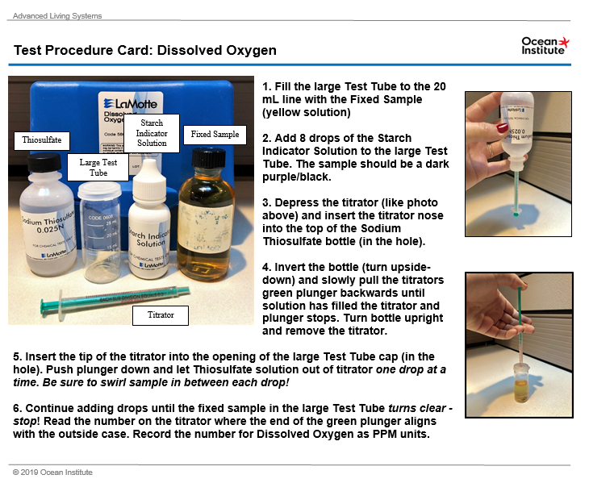

BACKGROUND INFO

Aquariums are miniature ocean ecosystems with both biotic and abiotic factors that affect each other. Aquarists must be aware of water chemistry so that they can maintain proper balances in the tanks. Learning the needs of each species, maintaining environments at a high quality, and spotting health problems early, before they spread to other animals in a tank, all are vital, daily challenges.

For information and instructions on each test, please see the individual test procedure cards.

Vocabulary
Abiotic – (opposite to biotic) non-living, a term used for characteristics and elements of the environment that influence the survival or reproduction of organisms but are not alive themselves. Examples are temperature, light, nutrients, etc.

Biotic – living.

Celsius (°C) temperature scale is a metric unit for measuring temperature. This scale is the most commonly used for science. On the Celsius scale, the freezing point of pure water is 0°C and the boiling point of pure water is 100°C.

Fahrenheit (°F) temperature scale is a scale used primarily in the United States in which the freezing point of pure water is 32°F and the boiling point of pure water is 212°F.

Hydrometer – an instrument that measures the salinity, or saltiness, of water. The hydrometer actually measures the density of water—the saltier the water is, the denser it is. Specific gravity is a unit of measurement used for density.

pH – “power of hydrogen"; scale from 0 – 14 that measures the concentration on hydrogen-ions in a substance. A pH range from 0 – 7 means the substance is acidic (tomatoes, battery acid), a value of 7 means the substance is neutral, and 7 – 14 means the substance is basic or alkaline (lye, detergent, soap). Sea water has a pH value of approximately 7.8 – 8.2.

Salinity – measure of the dissolved salts in seawater.

Specific gravity – unit of measurement for density and can be used to measure the salinity of water. Density is temperature dependent. Specific gravity decreases as temperature increases. The hydrometers we use are set for 20° C - 25°C. To get ppt salinity measurement you need to use a conversion chart for water at other temperatures.

Temperature – measurement of the average kinetic energy of the individual atoms of a substance or object.

Thermometer – an instrument that measures temperature. Thermometers contain a small amount of colored liquid. As the temperature rises, the liquid will expand and fill more of the tube. Our thermometers have a number of black marks on them. Each of these black marks counts as one degree. There is also a colored line (usually red or blue) going up the thermometer. Find the top of the colored line. It will end at or near one of the black marks. This is the temperature.

Dissolved Oxygen (DO)
Aquatic organisms, like terrestrial organisms, need dissolved oxygen to survive. Fish, invertebrates, plants, and aerobic bacteria all require oxygen for respiration.

Oxygen dissolves readily into water from the atmosphere at the surface until the water is saturated. Once dissolved in water, the oxygen diffuses very slowly, and distribution depends on the movement of aerated water caused by turbulence and currents, water flow, and thermal upwelling. Aquatic plants (algae and phytoplankton) produce oxygen as a by-product of photosynthesis.

The capacity of water to hold dissolved oxygen is limited by water temperature, salinity and the atmospheric pressure. These factors determine the highest DO level possible, even in well-aerated water.

